 Sept 2021 – New revisions to existing Extraordinary web site

General

All suggestions on following pages are initial and tentative as the site is re-worked. It is understood that Rob may have relative input to design or functionality as the process continues.

Overall objective is to simplify the site from the standpoint of viewing it for information or education and to allow the site to aid in doing some business.

A page by page recommendation will be the initial guide to changes, with amendments to come as questions or new insights emerge throughout the process. Pics and photo changes will occur, will try to have included those new pics as we go.

The name ‘Extraordinary Practice’ [ EP] … will be terminated and ‘Launch Oral Systemic Health” [ Lanch] will remain as the only focus

Name of web address will need to change to LaunchOSH.com [ we can discuss using all the words… Oral Systemic Health… or simply OSH ] Will need to register the new web address and pay for the use of the name.

Will need to make a ‘Launch’ Facebook link and new account when site is complete

**Home Page**

* **Top banner – delete EXP log and words. Replace with Launch logo and words… Launch Oral Systemic Health. Under those words – Speaking| Consulting. Email and phone on right – same. Color same**
* **Site navigation menu of options - Homepage [same] - Consulting/Training– Speaking - Products – Patient Education – About Us – Contact Us**
* **Launch Logo and words – leave about there**
* **The rotating pic/slide show – delete and save for the patient education page. Place a new pic to right of the logo**



**1**

* **delete and save the blue outlined words – save for under the rotation slide show in ‘Patient Education’**
* **Dark Blue banner - delete words, place new words - “ Periodontitis, simply gums that bleed, is directly linked to human wellness. Dentistry can reduce the impact of chronic diseases for our patients.” Tighten up the blue banner spaces, symmetry, etc. White letters.**
* **Delete the 3 pics and summaries under ‘training’, speaking, and About us… on the home page. Keep pics for later use on other pages**
* **Meet Dr John video – keep here for now. Change words “ when is enough , enough’ to – “Dentistry’s Call to Action”. Add the following new bullets adjacent to blue hearts –**

**[ may end up re-shooting an introductory message]**

* **Oral pathogens causal to atherosclerotic disease**
* **The microbe *Pg* now linked to onset of Alzheimer’s**
* **90% of heart attack patients have gums that bleed**
* **87% of diabetics have some form of periodontitis**
* **75% of preeclampsia episodes linked to oral bacteria**
* **60% of ora-digestive cancers now linked to patients with chronic PD**
* **More than 50% of cardiovascular events have an oral pathogen at the epicenter**
* **PD organisms raise hsCRP with no other confounding factors**
* **The same biofilm of pathogens found in the moth, are found on carotid artery walls in patients with bleeding gums**
* **The incidence of a CV event up 50% for four weeks after SRP**
* **Immune compromised patients do not naturally fight pathogenic attack**
* **Put the ‘America Unhealthy’ video from next page on right side of the above list- so the list is framed between both videos. Lets see if that can be engineered to look good, look neat, look attractive?**
* **Add blue banner under hearts - “ Dentistry can impact all the above – Wellness is enhanced with oral-systemic care”**

**________________________________________________________________________________________________________**

**Training/Consulting Page**

* **New top blue banner – as per Home page – Duplicate menu bar again**
* **New pic adjacent to Launch logo – thinking the pic on the old homepage at the training/consult drop down would work… lets start there, have some below, but they are patient centered … not really learning centered…?**

2

* 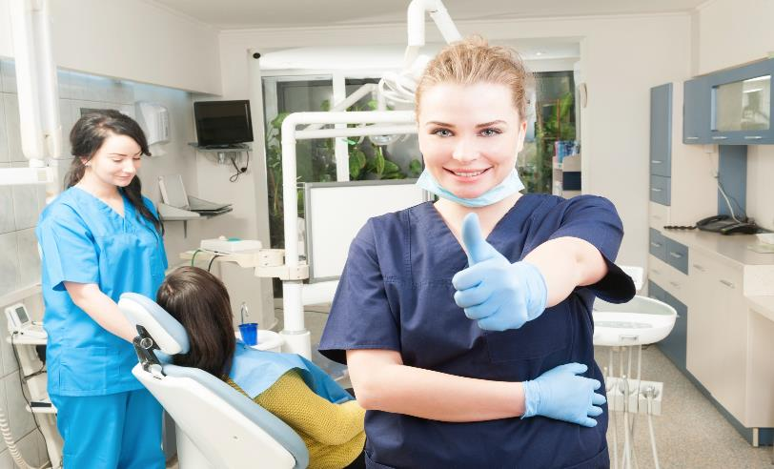



* 
* **Delete the blue lined box and content [ “ Oral systemic education…”]**
* **Move up dark blue banner and content**
* **Move ‘America is unhealthy to Homepage-**
* **Put John speaking at video – on John speaking page**
* **Move Oral systemic training video to left side, can enlarge to match content box to be placed on right of it- can that video be edited? Edit out EXP name and Traci?**
* **Content box to right of video – put the 5 check boxes that fall under the header ‘ One of a kind team experience – maybe some flashy red check marks!**
* **Workshop- blue banner- add word ‘Training’… just in front of ‘Workshop’ – rest the same – consider red stars to match the red check marks above?**

3

* **Same 12 step manual on left – same “contact us to Schedule” [change register to schedule]**
* **Put the right content …. participants will be able to: … in a content box – red stars to highlight ? Add one last star- “Be prepared to benefit from a more profitable hygiene department immediately”**
* **Move registration Information words down – Insert a blue banner, same as Workshop/Course title. New banner title - Customized Oral Systemic Coaching – Content specific to Your Needs. Place a ‘Contact Us to Schedule and Discuss” box adjacent to, or just below the banner. Lets use 2 or 3 photos [ thumbs up photos] from above to the right of the ‘Contact” button**
* **Registration Information- same words – push to left – over “single team”- “Zoom Consult” [ new add] – [delete 2 teams and 3 to 5 teams]**
* **Single team- all check marks same, except last one- delete ‘CE: 5,6 or 7 hours**
* **Change 2395$ to 2400$ and change the small words to say “ Airfare and 1 night lodging included”**
* **Change “Contact Us to “Schedule” now**
* **Add- Zoom Consult**
* **Arrange a convenient time**
* **One on one or multiple team members**
* **Team Training Syllabus**
* **Practice Resource Guide**
* **Follow up support as Needed**
* **Customized to client needs**
* **Fee based on hourly engagement**
* **Add Contact Us to Schedule and Discuss Details**
* **Place Photo of female DDS with OK sign –[ above]- to right of the content**
* **Refund info – same**
* **Delete all facilitator words**
* **Delete the next blue panel – “oral Systemic consult and practice management”**
* **Delete the ‘Accident waiting to happen Pic”**
* **Retain the referral section as is – may add to it later**
* **The final words – “ The implementation of oral medicine…’ NEED TO BE placed under the “Refund policy words”**
* **Last panel of Logos – each page – delete Directory of Dental speakers**
* **Find us on Facebook will need to change to “Launch OSH’ … after site is up again**
* **Contact Us – change EP to Launch – delete email Traci Warner**

**Speaking Page –**

**Delete Traci Warner page – save in a file if that works**

**John Speaking page-**

* **New top banner**
* **New menu bar**
* **Same Launch logo – with same photo to right**
* **Delete the content box with words**
* **Retain the second blue banner with words**

**4**

**Listing the presentations, topics, their order, changes to wording/content- under Hot topics**

1. **“Human Wellness and Periodontal Pathogens” [ red/brown color]**

**Transforming Dental Hygiene to Primary Care**

* **Use same photo in the “launch Oral Systemic Health: Transforming Dental Hygiene**
* **Use same content – in general –**
* **2nd paragraph – change – “… when or immune compromised patients walk in the door.”**
* **In 3rd paragraph – change – “ DR John presents current evidence that will convict the audience that dentistry must engage new practices to account for unmitigated oral bacteria in the immune compromised patient.” “ A specific set of easy to implement protocols for diagnosing and treating periodontitis with the goal of minimizing the disease’s systemic health impact on human wellness is reviewed.**
* **4th paragraph – A review of numerous clinical cases , outcomes, and personal stories frame this comprehensive overview. The presentation is a full day event.**
* **The ‘View course description button – delete for now nnd save the content of that to a file under the name “Human wellness and Periodontal pathogens”**

1. **Post Pandemic – Dentistry’s New Opportunity – red/brown color**

* **1st paragraph-** The COVID-19 pandemic of the past eighteen months has educated the adult patient population to understand the concept of immune compromised. Patients can better comprehend what systemic conditions have compromised their immunity and how this situation places their wellness at risk. Additionally, healthcare providers have become hypersensitive to systemic pathogenic insults to their patients. In general they have responded by protecting and supporting the immune system during the insult while fighting the pathogenic initiator. To date, the response has been reactive; it is timely for dentistry to be a proactive collaborator and partner in an intentional and strategic plan to strengthen the human immune system in the compromised patient.
* **2nd paragraph -** Dentistry’s private practitioners have been waiting for incentive, motivation, or endorsement from organizational leadership on what course of action they should be engaged in to optimally respond to periodontal disease in the immune compromised patient. This patient care opportunity offers dental practices new growth strategies and offers dentistry primary care status as we collaborate with peer physicians in behalf of patient wellness. May all of dentistry’s stakeholders be willing to evaluate our established standards of care for periodontal disease mitigation, consider an expanded perspective, and move forward with patient wellness as our highest priority. A one hour event.

5

* 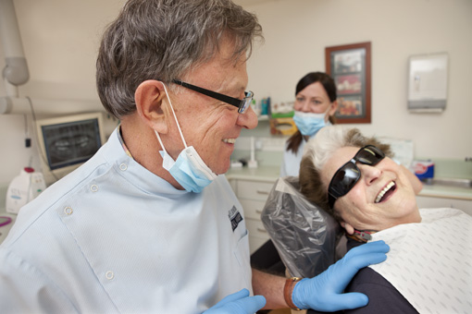

1. The New Standard of Care for Diagnosing and Treating Periodontal Disease- red/brown letters- same sub title words

* Same 1st paragraph
* Same 2nd paragraph
* Same 3rd paragraph- one or 2 hour event
* Delete 4th paragraph
* Same photo adjacent – delete view course description – save content in file

1. Antibiotic Stewardship – A new Perspective [ new title] red/brown color. Simplify sub-title to “Treating periodontitis according to the medical model” – delete rest of sub-title

* Same 1st paragraph
* Same 2nd paragraph
* Same 3rd paragraph – change last sentence to “1 or 2 hour event.”
* Same adjacent photo

1. Delete “ the Greatest biofilm thereat –“
2. Delete “Dentistry is Medicine”
3. Delete “ Stop the Accident waiting to happen”
4. Delete “Dentistry’s New big Question”
5. Save all “ coarse descriptions, by title, in a file for John
6. The last panel area on page –

* Transfer Dr John’s Bio to the About Us page
* Leave the Highlight seminal video in place
* I have some video from a spring 2021 seminar I put on… will eventually get it to you… have you cut and edit key moments… post a second video
* Leave the Dentistry Today post in place
* May have another article to post- in progress as we speak.
* Delete “Customize a presentation”
* Delete Directory of Dental speakers – thinking the John Maxwell also throughout?
* Delete Traci Warner email
* Email John Kempton DDS FACD FAAOSH [ the DDS is missing all the way along]
* The Facebook posting name will change to Launch OSH

6

**Product page –**

* **Same top banner changes**
* **Same menu changes**
* **Same Logo- new photo on right side –**
* 



* Delete content box
* Retain blue banner and words
* Retain Purchase …
* Retain manual pic and adjacent bullet points
* New Purchase price = $20.00
* I will be figuring how to change that with WordPress- now Kindle Publishing
* Will need to run a test on PayPal
* Rest of page- no changes
* Final banner- change EXP to Launch, change Traci name, add DDS to John Kempton, under ‘links- delete Traci… on all pages same

**About Us page**

* **Same changes to top banner**
* **Same changes to menu bar**
* **Change “About Extraordinary Practice” to About Launch Oral Systemic Health**
* **Same words in the banner box, same logo image**
* **Delete words “ Team Members”**
* **Delete the periods after each letter of DDS, FACD, and FAAOSH**
* **Add a sentence to end of actual bio- “Dr John has spoken in behalf of oral systemic health across the country and been published in peer reviewed journals. 7**
* **Delete speaker packet button**
* **The personal side- consider making all pics a little smaller ?**
* **Delete Traci segment**
* **Delete Directory of Dental Speakers- John Maxwell**
* **Contact Us – change EXP to Launch. Add DDS to John Kempton – Delete Traci – Links; delete Traci**
* **New Facebook connection to come**

**Contact Us page –**

* **Change top banner and top menu bar**
* **Delete Pursuing health and words below**
* **Move launch Oral Systemic log to left of page**
* **Move -Contact John to right, across from logo**
* **Change Contact John – to Contact Dr John**
* **Email change to John Kempton DDS FACD FAAOSH**
* **Add John’s POB 310, Paradise, CA here and Phone # here [ brite blue font]– delete the same form below TYtraci contact info**
* **Delete “Opportunity! And words below**
* **Delete contact Traci content**
* **Change Extraordinary Practice to Launch OSH**
* **Lower panel – Links, delete Traci.- Contact Us, change out EXP to Launch. Change to John Kempton DDS FACD FAAOSH. Delete Traci contact in lower right**
* **Place image of the manual about where it is… across form it, in same shade of blue… create a content box that is blue… with white printed content that says –**

**Dentistry’s Post-Pandemic Opportunity-**

**Patients are aware of the meaning of immune compromised-**

**They are the aware of the risks to their wellness this condition brings-**

**Dental teams know periodontitis diminishes the human immune response-**

**We are positioned to reduce risk factors for all disease by mitigating both local and translocated biofilms of oral pathogens while advocating for collaboration with physician colleagues.**